AUTOMATIC GATE USING INFRARED SENSOR

*by:ISHMWE DIDIER*

[Document subtitle]

**Active infrared sensors**

 Work with radar technology and they both emit and receive infrared radiation.

* This radiation hits the objects nearby and bounces back to the receiver of the device. Through this technology, the sensor can not only detect movement in an environment but also how far the object is from the device.

An infrared (**IR**) **sensor** is an electronic device that measures and detects infrared radiation in its surrounding environment

Infrared technology is employed in everyday life as well as in industry for various of purposes. The key advantages of IR sensors are their low power consumption, simple construction, and useful functionality. IR signals are undetectable to the naked eye. In the electromagnetic spectrum, IR radiation can be found in the visible and microwave ranges.

Wavelengths of these waves typically range from 0.7 m 5 to 1000 m. Near-infrared, mid-infrared, and far-infrared are the three sections of the IR spectrum. The wavelength extends from 0.75 to 3 metres in the near infrared region, 3 to 6 metres in the mid-infrared region, and more than 6 metres in the far IR zone.In this blog will be talking about the IR sensor working principle and its applications.

**What is an IR Sensor/Infrared Sensor?**

An infrared sensor is an electrical sensor that detects and measures infrared light emitted by an object or its surroundings. The IR sensor emits or detects infrared radiation to identify certain features in its surroundings. These sensors can also detect or measure a target’s heat as well as its motion. The IR sensor circuit is a critical component in many electronic devices.

This IR Sensor consists of two parts, a Transmitter, and a Receiver. The transmitter emits IR light, and the object reflects that light. The photodiode (receiver) receives the reflected light. The amount of reflection and reception varies with distance. These differences cause a change in the input and thus used for proximity detection. IR LED sensor module has both the transmitter and emitter designed to work on the 940 nm wavelength.

A typical infrared detection system consists of five fundamental components: an infrared source, a transmission channel, an optical component, infrared detectors or receivers, and signal processing. Infrared sources include infrared lasers and infrared LEDs with specified wavelengths.

Vacuum, atmosphere, and optical fibers are the three basic types of media utilized for infrared transmission. Optical components are used to focus or limit the spectrum response of infrared radiation.

**Specifications:**

* The operating voltage is 5VDC
* I/O pins – 3.3V & 5V
* Mounting hole
* The range is up to 20 centimeters
* The supply current is 20mA
* The range of sensing is adjustable
* Fixed ambient light sensor

**Types of Infrared Sensor**

Infrared sensors are classified into two types like active IR sensor and passive IR sensor.

**Active IR Sensor**

The transmitter and receiver are both included in this active infrared sensor. The light-emitting diode is employed as a source in the majority of applications. A non-imaging infrared sensor is an LED, while an imaging infrared sensor is a laser diode.

These sensors operate on the basis of energy radiation, which is both received and detected. It can also be processed by utilising a signal processor to retrieve the relevant data. Reflectance and break beam sensors are the best examples of this active infrared sensor.

**Passive IR Sensor**

The passive infrared sensor consists only detectors and does not include a transmitter. These sensors make use of a transmitter or an infrared source. This object generates energy that infrared sensors detect. After that, a signal processor is utilised to decode the signal and extract the necessary data.

They are divided into two categories: quantum and thermal. Infrared radiation is used as a heat source in thermal infrared sensors. Thermal infrared detectors include thermocouples, pyroelectric detectors, and bolometers. Infrared sensors of the quantum kind have a better detection performance. It is faster than infrared detectors of the thermal kind. Quantum type detectors’ light sensitivity is wavelength dependant.

**IR Sensor Working Principle**

An infrared sensor works similarly as an object detection sensor does. This sensor contains an infrared LED and an infrared photodiode, which can be combined to make a photo-coupler or an optocoupler. Planks radiation, Stephan Boltzmann, and Weins displacement are the physics laws used in this sensor.

**IR Transmitter or IR LED**

Infrared Transmitter is a light emitting diode (LED) which emits infrared radiations called as IR LED’s. Even though an IR LED looks like a normal LED, the radiation emitted by it is invisible to the human eye.

**IR Receiver or Photodiode**

IR Photodiode functions as an IR receiver used to detect the light rays reflected from an IR LED.  The photodiode is basically a reverse-biased PN junction diode. When the photodiode is exposed to light, the electrical resistance across the diode decreases. Thereby increasing the reverse current. In case if the photodiode is not exposed to light, the resistance across the diode will be high. Hence the reverse current will be extremely small. This current is also known as a dark current.

There are various types of IR receivers based on wavelength, voltage, packaging, and other factors. The wavelength of the receiver should match that of the transmitter when utilised in an infrared transmitter – receiver combo.

These lights are not visible by naked eyes but can be seen through a camera. That is the reason why these IR sensors used in night vision cameras. When light falls on the IR sensor, the photodiode response in terms of change in resistance. This change in resistance measured in terms of voltage. This module can be connected directly to a microcontroller, Arduino, or Raspberry Pi with a few current limiting resistors.

**IR Sensor Circuit Diagram**

This IR Sensor circuit comprises the following components

* **LM358 IC** 2 IR transmitter and receiver pair
* Resistors of the range of kilo-ohms.
* Variable resistors.
* LED (Light Emitting Diode).

The transmitter part of this project includes an IR sensor that emits continuous IR rays that are received by an IR receiver module. The receiver’s IR output terminal changes depending on how well it receives IR photons. This output can be passed to a comparator circuit because this variation cannot be analysed separately. As a comparator circuit, an LM 339 operational amplifier (op-amp) is employed.

When the IR receiver does not receive a signal, the inverting input of the comparator IC has a higher potential than the comparator IC’s non-inverting input (LM339). As a result, the comparator’s output goes low, but the LED does not glows. The voltage at the inverting input goes low when the IR receiver module gets a signal. As a result, the comparator’s output (LM 339) turns high, and the LED begins to glow.

Resistor R1 (100 ), R2 (10k ), and R3 (330) are used to ensure that a minimum of 10 mA current passes through the IR LED Devices like Photodiode and normal LEDs respectively. Resistor VR2 (preset=5k ) is used to adjust the output terminals. Resistor VR1 (preset=10k ) is used to set the sensitivity of the circuit Diagram.

**Advantages**

* Low power consumption
* There is no data leakage because of the ray direction
* These sensors are not affected by oxidation & corrosion
* Noise immunity is strong
* Detects motion when the light is present or absent
* These sensors are not affected by rust
* They do not need to get in touch with objects for detection.
* No data leakage because of the directionality infrared radiation of ray
* These are more modest in size and are more moderate.
* It responds very quickly as compared to thermocouples.
* It provides high reliability

**Disadvantages**

* Line of sight is required
* Range is limited
* These can be affected by fog, rain, dust, etc
* Less data transmission rate
* These sensors can be blocked with common objects.
* High force IR signals can harm human eyes

**IR Sensor Applications**

IR sensors are classified into different types depending on the applications. IR sensors are used in a variety of projects and electronic devices. The following are some of them:

* Climatology
* Meteorology
* Photobiomodulation
* Flame Monitors
* Gas detectors
* Water analysis
* Moisture Analyzers
* Anesthesiology testing
* Petroleum exploration
* Rail safety
* Gas Analyzers

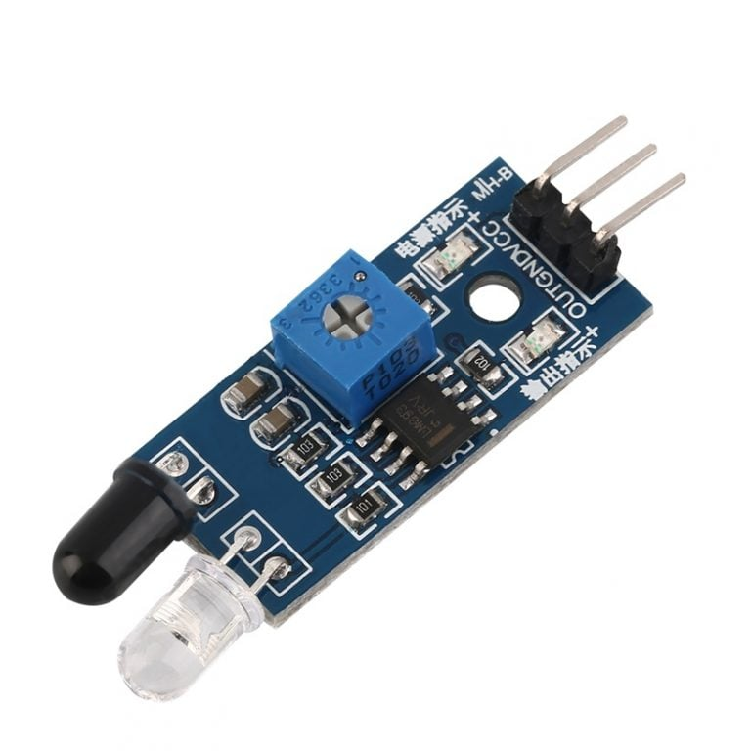

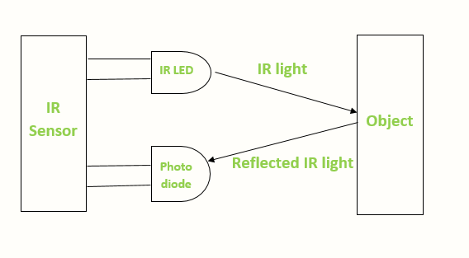

CODE

#include <Servo.h>

Servo gate; // create servo object to control the gate

int ir1 = 2; // set IR sensor 1 pin

int ir2 = 3; // set IR sensor 2 pin

int car_count = 0; // variable to keep track of number of cars in the parking spot

void setup() {

gate.attach(9); // attach the servo to pin 9

pinMode(ir1, INPUT); // set IR sensor 1 as input

pinMode(ir2, INPUT); // set IR sensor 2 as input

}

void loop() {

if (digitalRead(ir1) == HIGH && car_count == 0) {

// if car enters the parking spot and there are no cars parked

gate.write(90); // open the gate

delay(0000); // wait for the car to pass

gate.write(0); // close the gate

car_count = 1; // increment the car count

}

if (digitalRead(ir2) == HIGH && car_count == 1) {

// if car exits the parking spot and there is one car parked

gate.write(90); // open the gate

delay(1000); // wait for the car to pass

gate.write(0); // close the gate

car_count = 0; // decrement the car count

}

}

